4B OS LAB-07 ASSIGNMENT

# **Muhammad Danish | cs182019 | 4B**

**Round Robin Scheduling**

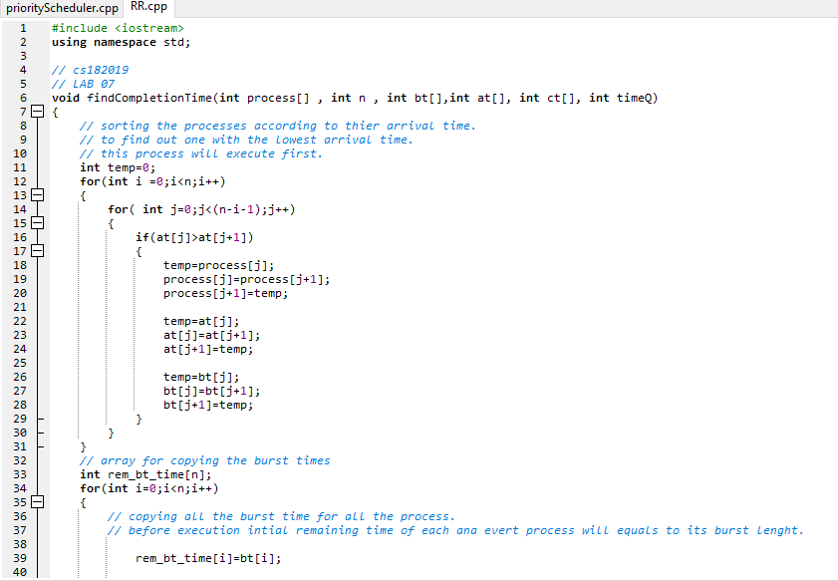

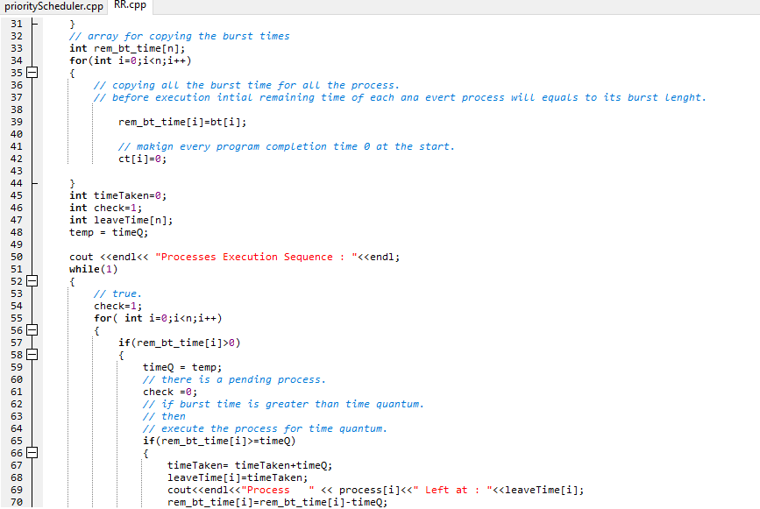

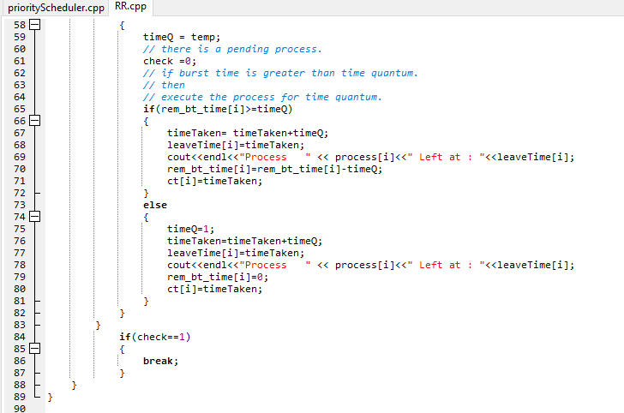**\*FIND_COMPLETION_TIME FUCNTION END HERE.**

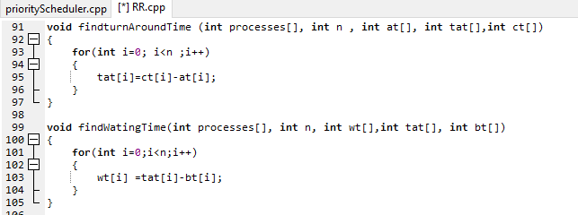

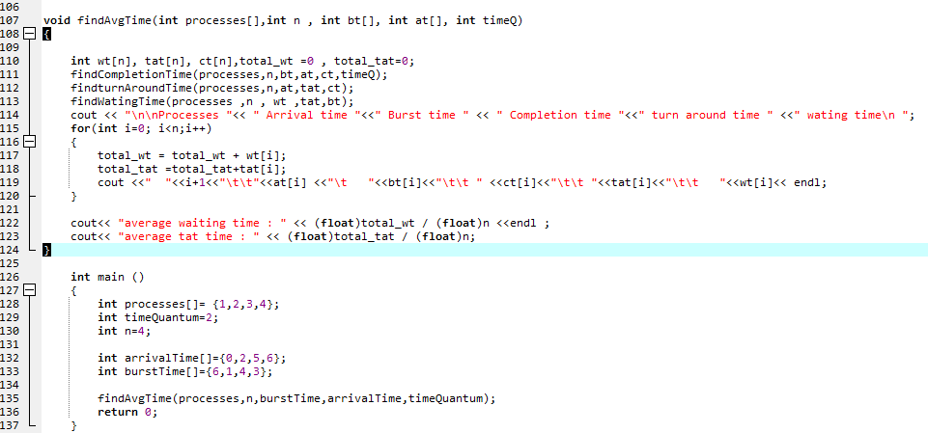

**ROUND ROBIN SCHEDULING CODE OUTPUT**

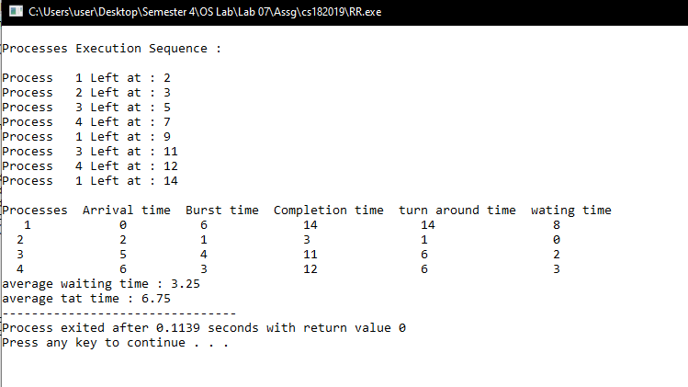

**Priority Scheduling**

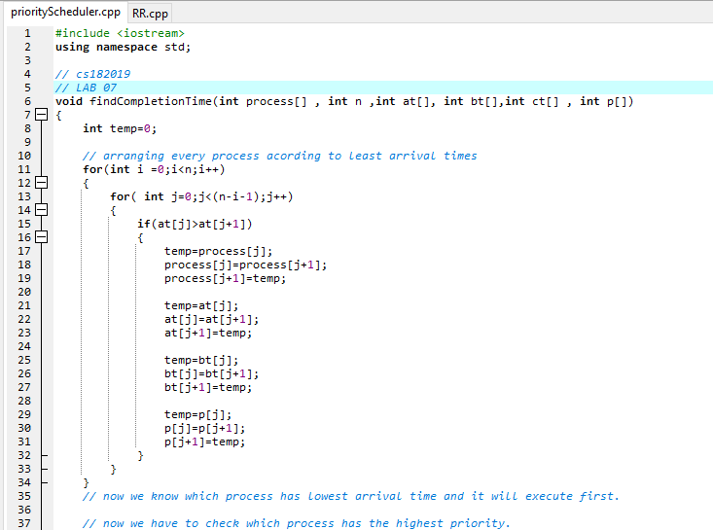

Continued….

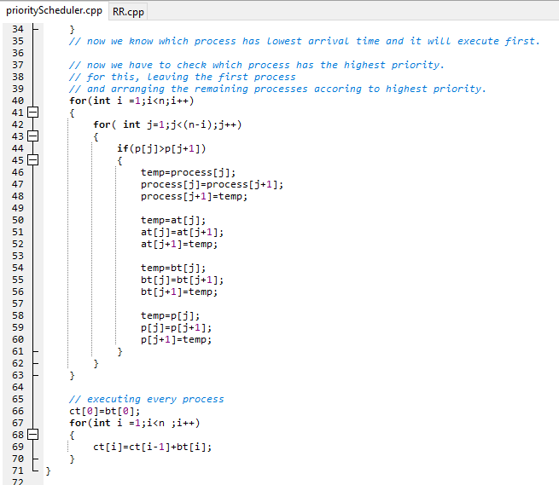

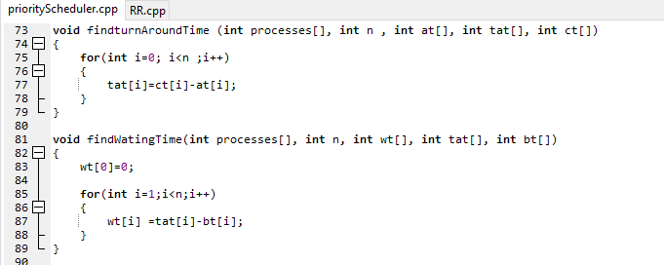

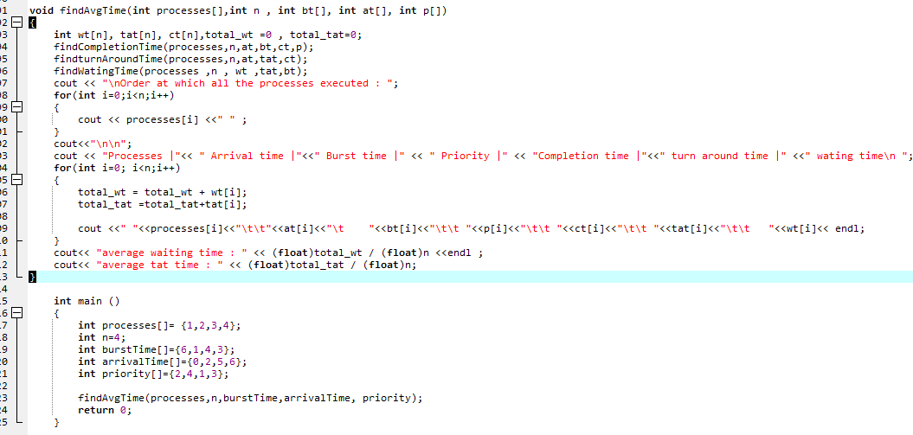

**PRIORITY SCHEDULING CODE OUTPUT**

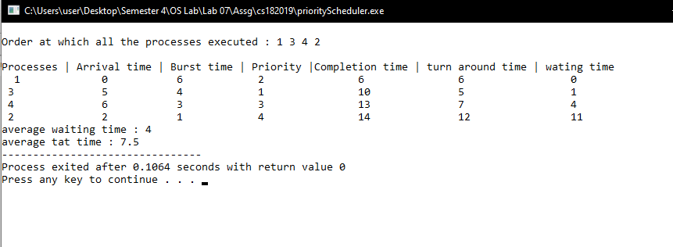

Muhammad Danish | cs182019 |4b